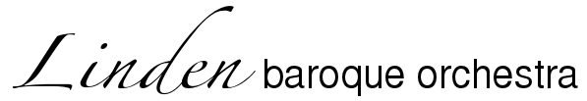
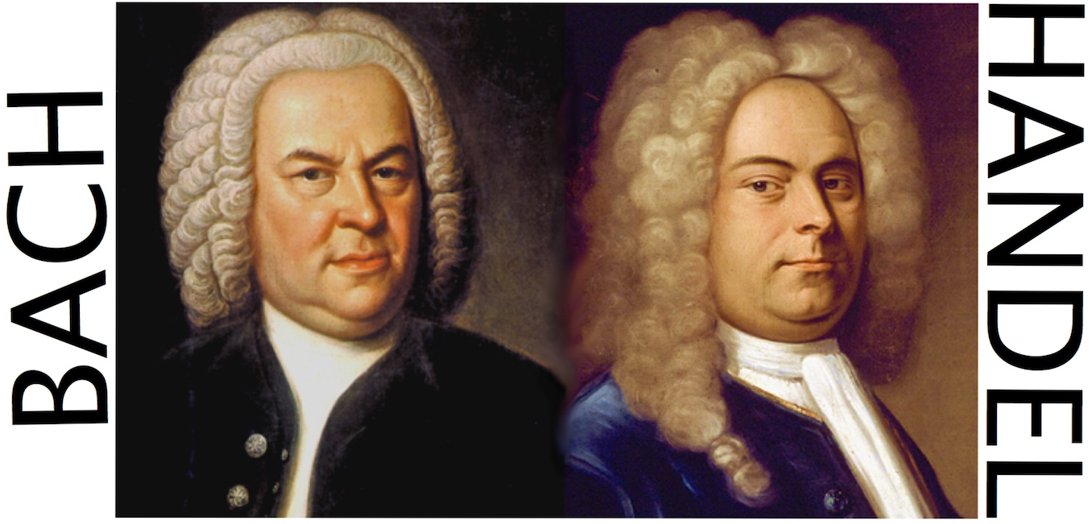

Concert Programme October 23rd 6.30pm St Stephen’s, Hampstead

Director / Solo Harpsichord Steven Devine

Bach Sinfonia to Cantata 209 Solo flute Richard Austen
Handel Concerto Grosso Op. 3 No. 5 Andante – Allegro – Adagio – Allegro ma non troppo – Allegro
Bach Triple Concerto BWV 1044 Allegro – Andante ma non tanto e dolce – Allebreve Solo harpsichord Steven Devine, violin Ben Samson, flute Richard Austen
** Interval **
Handel Concerto Grosso Op. 6 No 3 Larghetto – Andante – Allegro – Polonaise – Allegro ma non troppo
Bach Orchestral Suite No 1 in C major BWV 1066 Ouverture – Courante – Gavotte 1 & 2– Forlane – Menuet 1 & 2 – Bouree 1 & 2 – Passpied 1 & 2

Bach and Handel, the two giants of baroque music, were very different animals. They were born in 1685 just a month and 150 km apart, Bach into a family of musicians, Handel into a family disapproving of his musical ambitions. Their personalities led them down different career paths but their music achieved similar levels of greatness. Our concert explores aspects of their varied orchestral output highlighting differences and similarities, influences and developments.

It is interesting to compare the two portraits of the great composers on the programme cover and see if they offer any hints as to their musical personalities. The picture of Bach in his early 60s is by Hausmann and that of Handel, probably in his late 40s.

J.S.Bach was stubborn, difficult, impatient, irascible (he once pulled a dagger to a bassoonist – and who could blame him? - but that was in self-defence after Bach had compared his playing with the sound of a bleating goat). Most of all he was exacting and his standards almost supernatural. He was also deeply religious. But off-duty, with a pipe and a few drinks, he could be good humoured and was known to enjoy singing dirty rounds. His music was not widely known in his lifetime. It was considered somewhat old fashioned and rarified and as Bach was not very commercially minded and travelled little, his music did not spread far and wide like Handel’s. Bach was primarily known as a remarkable keyboard player and improviser. However belligerent he might have been, his compositions often display a different aspect: though frequently grand, extraordinarily complex, rhythmically buoyant and harmonically rich, they can also be elegant, charming and witty.

Handel, on the other hand, was much more outward looking, a socialite, at the centre of London’s public music making and always searching for a commercial opportunity to exploit. He was a large personality, fitting his large frame and fuelled by a large appetite for food and drink. He was a loyal friend to many and though he could be irritable, he bore no grudges and was a kind and humorous companion who generously supported many charities. As well as his great success he had some major downturns but always bounced back. Handel never married whereas Bach produced 20 children from his two marriages (though ‘only’ 8 made it to adulthood). Handel was thus able to remain an independent artist seeking patronage as needed whereas Bach required a permanent position, whether at court or church, in order to feed his family. Bach was more constrained by the demands of his employers than Handel, though Handel had to obey market forces- the whims of the public mood and taste and that of the impresarios and publishers he provided for. His music was instantly accessible, popular and melodic, largely written for the public and Handel could always create a great impression, underpinned with integrity and depth.

Though they never met, Bach and Handel unfortunately shared the same eye surgeon, John Taylor of London. He was a cataract surgeon and something of a charlatan, blinding hundreds of people, by his own confession. Indeed it is suggested he hastened Handel’s blindness and complications following Taylor’s interventions may have contributed to Bach’s demise. Handel outlived Bach by 9 years.

Beethoven said of Handel "He is the greatest composer that ever lived. I would uncover my head and kneel before his tomb" and of Bach “The immortal god of harmony”.

Johann Sebastian Bach (1685–1750) was born into a tradition of professional music making, one of a large and sprawling musical family. His parents died when he was nine years old and he went to live with his brother Johann Christoph, an organist and his first teacher. Each of his five principal posts enabled him to develop different sides of his immense talent. In the courts of Weimar from 1708 and later in Köthen from 1717, he was free from some of the onerous obligations of the Lutheran Church Cantor that were to afflict him with such glorious results in his last and most fertile appointment in Leipzig. In Köthen he was able to study the extensive library collections of his employer, Prince Leopold, who was himself a good musician and possessed a fine orchestra of around 18 players and it was during this period of his career that he wrote most of his instrumental works including, most likely, the Orchestral Suites.

George Frideric Handel (1685-1759) was born to a barber-surgeon in Halle whose aim for his
son was to study law. The Duke of Saxe-Weissenfels had a high opinion of the lad and persuaded his father to let him study music with a church organist, Zachow. Handel seems to have received a good grounding in composition in all the current styles, learning by copying out the works of other composers, a practice which stood him in good stead for his later many ‘borrowings’. He obtained his first professional post as church organist in 1702 and the following year left Halle for Hamburg where he played in the back desk of the violins at the opera and filled in on the harpsichord. Handel quickly rose through the ranks to direct operas and became a central part of the organisation. Hamburg was a major port with strong links to Italy in particular. A traveller, Gian Gastone de’ Medici, befriended Handel and persuaded him he needed to acquire a first hand Italian musical education. He stayed there from 1706-10, spending time, at least in Florence, Rome, Naples and finally Venice. It was in Italy that Handel assimilated Italian music and developed his love of writing for the voice, eventually ending up writing around 40 operas as well as many cantatas and oratorios. On return from Italy Handel was appointed Kapellmeister in Hanover. The Elector of Hanover, of course, later became George 1st but by then Handel had already established himself in London, a major centre of musical activity at the time.

Bach’s Cantata 209 ‘Non sa che sia dolore’ (“He knows not the meaning of sorrow”) is one of Bach’s small number of secular cantatas and is a bit of a mystery. The text is a crudely translated mishmash and even the authenticity of the complete piece has been questioned, though it is of high quality. It seems to have been written for the departure of a close friend or pupil of Bach’s. The opening sinfonia may have been a movement of a lost Bach flute concerto.

The Concerto Grosso pits small ‘concertante’ groups of instruments against the ‘ripieno’ band. It was a form prevalent in Italy and Corelli was the greatest exponent. Handel actually played in Corelli’s orchestra in Rome and obviously learned much from the master though his own such pieces are often more varied. Handel’s own twelve Opus 6 “Grand Concertos” were composed in 1739 over the space of only six weeks at the suggestion of his publisher, John Walsh. They are clearly inspired by Corelli’s examples, maybe even a conscious homage and are among his finest works. They caused much excitement and were widely praised. Handel took particular trouble over the publication and one hundred subscribers paid for the careful engraving.
The Opus 3 set, in contrast, were arranged from variety of other works into a set and published without Handel’s prior knowledge by John Walsh in 1734 in order to capitalise on the craze for such works following the success of his publication of Corelli’s Opus 6 collection.

Bach’s Triple Concerto is a rather curious work from Bach’s later years in Leipzig, reworking other material – the Prelude and Fugue in A Minor for keyboard BWV 894 in the outer movements and the Trio Sonata for Organ in D min BWV 527 being remodelled to form the lovely middle movement, which is for the three soloists alone.

Orchestral Suites based on French models were very popular in 18th century German courts and hundreds were churned out by German composers. They begin with a typical grand French ‘Ouverture’, the term also entitling the whole piece, which was often associated with theatre music or opera-ballets in France and was developed in particular by Lully. The slow introduction is followed by a faster fugal section. After this formal opening, there follows a succession of traditional dance movements. Bach often relaxed from his official duties by providing music for - and later taking over - the Collegium Musicum, a society started by his old friend Telemann and it was here that much of his earlier instrumental music was resurrected, either in its original, or arranged form and this is where a where this and the other orchestral suites resurfaced in copied parts, the original scores having been lost.

Steven Devine is one of the most sought-after and versatile musicians in the country. After education at Chetham’s School of Music, Manchester and Oxford University, he won the inaugural Broadwood Harpsichord Competition in 1994. Since then he has enjoyed a career across the world as a harpsichordist and conductor. His recording of Bach’s “Goldberg Variations” for the Chandos label was described as “one of the best” by Gramophone Magazine. He is currently completing a three-disc survey of the harpsichord music of Jean-Philippe Rameau for Resonus and will record Bach’s monumental Art of Fugue next year. He has made over fifty recordings with other artists and orchestras.
Currently he is Curator of Early Music for the Norwegian Wind Ensemble – he regularly tours Norway with them and has just returned from a tour of Bolivia. Recent guest directing appearances have included the Victoria Baroque Players and Arion in Canada as well as Trondheim Barokk. Steven has directed the Orchestra of the Age of Enlightenment across Europe and Asia and with them he co-directed the award-winning recording of Purcell’s “Dido and Aeneas” with Sarah Connolly in the title role. For Raymond Gubbay Productions he has conducted the much-loved “Carols by Candlelight” at the Royal Albert Hall for many years and also “Mozart Masterpieces”, “Handel by Candlelight” and the Mozart Requiem. As the Music Director for New Chamber Opera, Oxford, he has conducted productions of a huge range of repertoire from Cavalli’s “L’Erismena” to Rossini’s “Le Comte Ory”.
Steven is on the staff for TrinityLaban Conservatoire of Music and Dance and a visiting Professor at the Royal Welsh College of Music.

Linden Baroque was formed in late 1984 by a group of early music enthusiasts in the front room of a house in Linden Gardens, Chiswick. Unusually - and uniquely anywhere at that time – it combines the talents of young professionals, amateurs and students and many members have moved on to have prominent careers in the early music field. From the beginning, the musical director was the well-known baroque oboist Paul Goodwin. Now pursuing a busy international conducting career, Paul is Honorary President and Steven Devine, following Walter Reiter, as Musical Director. The orchestra has played at venues from Norfolk to Rome (where it gave the first performances there of Purcell’s King Arthur) and last year to Berlin. The instruments are either 18th century originals or modern copies - some made by the players themselves and we play at “baroque pitch” of 415Hz.
Together with the Linden Baroque Choir we gave first modern performances of music by Jean Gilles and J F Fasch. Our first CD, issued in 2001 on the Meridian label of music by Fasch, was well received and was played on Radio 3 and Classic FM.
Linden Baroque is a registered Charity (No 1014921) and, apart from receiving a National Lottery grant in 1999, is entirely self-supporting. We are always looking for sponsorship for individual events or series!

L I N D E N B A R O Q U E O R C H E S T R A

Violin 1: Ben Sansom (Leader / solo violin), Jocelyn Slocombe, Claire Sharpe, Alan Selwyn, Barbara Grant, Rebecca Collen
Violin 2: Michael Jenner, Judy Taylor, Ian Cutts, Hannah Barker, Simon Hill
Viola: Mike Blee, Clive Letchford, Andrew Spencer, Matthew Le-Mage
Cello: Christine Draycott, Mary Walton
Bass: John Mears
Oboe: Simon Galton, Lysander Tennant
Bassoon: Mathew Dart
Flute solo: Richard Austen
Continuo harpsichord: Christine Thornton

Future concerts:
November 19th, 6.30pm St Paul's Church, West St. Brighton
Handel Dixit Dominus, Mozart Mass D maj K194 with Brighton Chamber Choir
December 22nd, 7.30pm St James, Piccadilly
Handel Messiah directed by Peter Fender
March 5th, 6.30pm St Stephen's, Hampstead
Bach Cantata 198 'Lass furstin', Telemann Lutheran Cantata 'Herr, wir liegen fur dir'
Telemann Suite for Viol da Gamba and strings Directed by Ibi Aziz

We would like to thank Prof. Peter Holman for lending us musical parts and wish him a very happy 70th Birthday!
www.lindenbaroque.org Prog. AS

